
SCSE 2123: Software Requirements Engineering
Semester 01, 2025/2026

User Requirements Definition

Etiqa Digital Payout (eMoney platform)

Version 1.0

6/12/2025

Prepared by: Visionscope
Think Out of the Box

DOCUMENT CONTROL
General Information
Document Name | : | URD1114 – User Requirements Definition
Audience | : | Etiqa Stakeholder
Prepared by | : | Visionscope
Prepared Date | : | 15/11/2025
Revision Date | : | 6/12/2025
Printed Date | : | 6/12/2025
Reference Number | : | 1114
Version | : | 1.0
Document Level | : | Confidential | Open

- Current Version Document
 | Name | Designation | Signature | Date
Prepared by: | Lee Ming Da  Tan Choon Da  Gan Rui En  Mohammed Mohsen Mohammed Al-Sakkaf | Moderator  Project Manager  Task Manager  Skeptic and Recorder |  | 6/12/2025  6/12/2025  6/12/2025  6/12/2025
Verified by: | Dr. Noraini Ibrahim | Head of Project | TBD | TBD

Table of Contents

No. | Item | Page # | Prepared by: | Moderated by:
1.0 | INTRODUCTION |  | Mohammad | Gan Rui En
1.1 | Purpose
1.2 | Scope
1.3 | Definitions, Acronyms and Abbreviations
1.4 | References
1.5 | Overview
2.0 | PROPOSED SYSTEM VISIONS |  | Tan Choon Da | Lee Ming Da
3.0 | AS-IS (CURRENT) PROCESS ANALYSIS |  | Lee Ming Da | Tan Choon Da
3.1 | <<As-Is Process #1>>
3.1.1 | Swimlane Model
3.1.2 | Related Documents
3.1.3 | Issues in current process
3.1.4 | Improvement Suggestion
3.2 | <<As-Is Process #2>> |  | Lee Ming Da | Gan Rui En
3.2.1 | Swimlane Model
3.2.2 | Related Documents
3.2.3 | Issues in current process
3.2.4 | Improvement Suggestion
4.0 | PROPOSED (TO-BE) PROCESS |  | Gan Rui En | Tan Choon da
4.1 | <<To-Be Process #1>>
4.1.1 | Swimlane Model
4.1.2 | Related Business Rules
4.n | <<To-Be Process #2>> |  | Gan Rui En | Lee Ming Da
4.2.1 | Swimlane Model
4.2.2 | Related Business Rules
5.0 | APPENDICES |  | Tan Choon Da

INTRODUCTION
This document sets out the User Requirement Definition (URD) for the Etiqa Digital Payout, via eMoney. It provides comprehensive requirements that state the business needs for transitioning from the current manual payout process to an automated digital eMoney ecosystem. This section gives background, scope, and definition that support the detailed requirement in subsequent sections
  - Purpose
This document sets out the User Requirement Definition (URD) for the Etiqa Digital Payout, via eMoney. It provides comprehensive requirements that state the business needs for transitioning from the current manual payout process to an automated digital eMoney ecosystem. This section gives background, scope, and definition that support the detailed requirement in subsequent sections.
The intended audience for this URD includes:
- Project Stakeholders (Etiqa Management): To ensure the system aligns with business strategies and financial inclusion goals.
- System Developers & Integrators: To understand the technical requirements for integrating the eMoney wallet with the existing Etiqa+ app and Maybank infrastructure.
- Compliance & Risk Officers: To verify adherence to Bank Negara Malaysia (BNM) e-money guidelines and the Risk Management in Technology (RMIT) framework.
- Quality Assurance (QA) Testers: To define test cases based on the specified requirements.

  - Scope
The software product to be produced is the Etiqa eMoney Platform, an embedded digital wallet feature within the Etiqa ecosystem.
The system will:
- Automate Payouts: Instantly credit policy claims, refunds, surplus sharing, and cashback rewards into the customer's eMoney account.
- Enable Transactions: Allow customers to withdraw funds to verified bank accounts or seamlessly reinvest them into new Etiqa insurance/Takaful products.
- Provide Transparency: Display real-time transaction history and payout status to customers.
- Ensure Compliance: Enforce security controls and reporting as per BNM and RMIT standards.
The system will NOT:
- Function as an open-loop e-wallet for general retail payments outside of Etiqa’s partner network; it operates primarily as a closed-loop system to encourage reinvestment.
Benefits and Goals: The primary goal is to replace slow manual bank transfers with instant digital crediting, thereby enhancing customer satisfaction and operational efficiency.

  - Definitions, Acronyms, and Abbreviations
Term / Acronym | Definition
URD | User Requirements Definition.
eMoney | Electronic money: a digital payment instrument where funds are stored electronically.
Etiqa+ | The official mobile application and digital platform for Etiqa customers.
BNM | Bank Negara Malaysia (The Central Bank of Malaysia).
RMIT | Risk Management in Technology: a policy framework by BNM that the system must comply with.
As-Is | The current state of the process (Manual Bank Transfers).
To-Be | The proposed future state of the process (Digital eMoney System).
Closed-loop | A payment system where funds are primarily used within the issuer's ecosystem.

  - References
- Case Study: Etiqa Digital Payout (via eMoney) in Accelerating Customer Disbursements and Reinforcement of Financial Inclusion.
(2025). Faculty of Computing, Universiti Teknologi Malaysia.
- Bank Negara Malaysia. (2023).
Risk Management in Technology (RMIT) Policy Document.
- Wiegers, K., & Beatty, J. (2013).
Software Requirements (3rd ed.). Microsoft Press.
- IEEE Std 830-1998, IEEE Recommended Practice for Software Requirements Specifications.

  - Overview
The remainder of this URD document is organized as follows:
- Section 2.0: Proposed System Visions This section articulates strategic objectives of the new system using a Goal Model, wherein high-level business goals are decomposed into specific sub-goals.
- Section 3.0: As-Is process analysis describes the current manual payout workflow. It will incorporate Swimlane diagrams to identify bottlenecks, delays, and dependencies in the existing bank transfer process.
- Section 4.0: This section defines the future automated workflow for the eMoney system, including the "To-Be" Swimlane diagram and the specific Business Rules that govern the new process.
- Section 5.0: Appendices. This section contains supporting materials, including the originality report and evidence of tools used during the elicitation process.
.

PROPOSED SYSTEM VISIONS
2. Goal Model
System Vision and Goal Diagram Description
The vision of the proposed Etiqa eMoney Payout System is to establish a unified, secure, and efficient digital payout ecosystem that enhances customer satisfaction while complying with regulatory and security requirements. It also aims to smoothen payout processing, support reinvestment, enhance security controls, and improve operational efficiency across Etiqa's digital platforms.

The Goal Diagram (Figure 2.1) visually represents this system vision by decomposing the top-level goal (G0: Provide a secure, fast, and reliable eMoney payout ecosystem for Etiqa customers) is expanded into eight major goal areas:
- G1: Enable instant and accurate payout processing
- G2: Support customer reinvestment into Etiqa products
- G3: Enable secure withdrawal to bank accounts
- G4: Strengthen security & compliance (RMiT, AML/CFT)
- G5: Improve operational efficiency and reliability
- G6: Enhance customer experience and trust
- G7: Provide a unified and centralized payout platform
- G8: Provide real-time transparency and fund visibility

These high-level goals are further broken down into detailed operational goals, which represent the specific behaviors, rules, and capabilities that the system must provide. The hierarchical decomposition of the root goal into structured sub-goals using both AND and OR decomposition provides a clear, high-level understanding of how the proposed system will achieve its overall objective. The diagram captures how system vision is supported by both functional and non-functional requirements.

Explanation of the Goals Decomposition (AND/OR)
The goal diagram uses a combination of AND and OR decompositions to represent how each goal contributes to achieving the overall vision.

- AND-Decomposition
Most top-level goals use AND decomposition, meaning that every sub-goal must be achieved to fulfill the parent goal. For example, to fulfill the root goal (G0), the system needs to achieve all G1, G2, G3, G4, G5, G6, G7 and G8 to provide a secure, fast, and reliable eMoney payout ecosystem for Etiqa customers.
Another example, to achieve G1, the system must match customer-bank data accurately, validate payout information, handle duplicate prevention, and implement fallback payout mechanisms. All of these are necessary to ensure reliable payout execution. Thus, G1 = G1.1 AND G1.2 AND G1.3 AND G1.4. AND decomposition ensures completeness by requiring all supporting goals to be met.

- OR-Decomposition
Some goals can be fulfilled through multiple alternative options, where satisfying any one alternative is sufficient. OR decomposition is used where the system may choose from several valid mechanisms.

For example, for archiving the (G1.2 Automate fallback payout mechanisms), the system may either (G1.2.1 retry eMoney auto-credit), OR (G1.2.2 fallback to manual bank transfer).

Another example, to archive the (G3.1 High-risk action authentication), secure withdrawal can be authenticated OTP, OR Mobile-App MFA, OR device-based verification.
Summary of AND/OR usage
- AND-decomposition captures required components needed to achieve mission-critical goals such as security, accuracy, compliance and reliability.
- OR-decomposition introduces flexibility where multiple methods or channels can accomplish the same objective like authentication, notification or fallback.

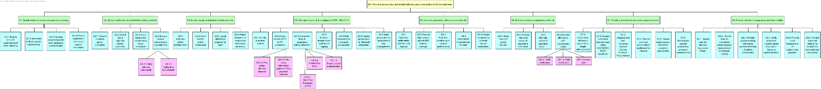
Figure 2.1: Goal Model of <Proposed Etiqa eMoney Payout and Reinvestment System>

Figure 2.2: G0: Provide a secure, fast, and reliable eMoney payout ecosystem for Etiqa customers
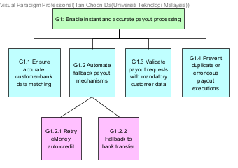
Figure 2.3: G1: Enable instant and accurate payout processing
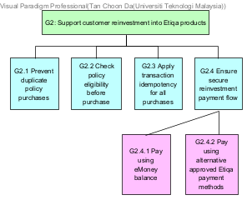
Figure 2.4: G2: Support customer reinvestment into Etiqa products
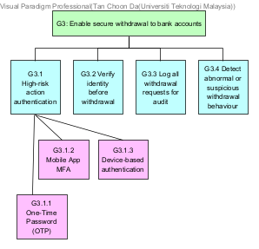
Figure 2.5: G3: Enable secure withdrawal to bank accounts
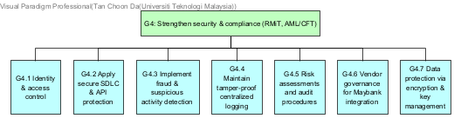
Figure 2.6: G4: Strengthen security & compliance (RMiT, AML/CFT)
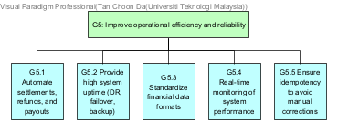
Figure 2.7: G5: Improve operational efficiency and reliability

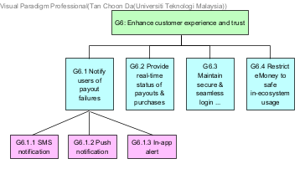
Figure 2.8: G6: Enhance customer experience and trust
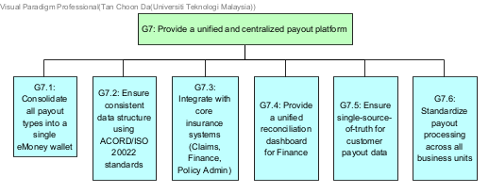
Figure 2.9: G7: Provide a unified and centralized payout platform
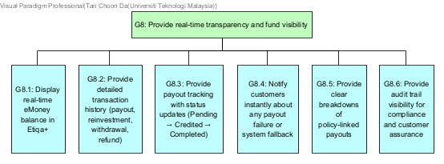
Figure 2.10: G8: Provide real-time transparency and fund visibility

AS-IS (CURRENT) PROCESS ANALYSIS

  - << Manual Bank Payout Process>>
The current payout process at Etiqa relies heavily on traditional bank transfers as the primary method for disbursing payouts such as claims, refunds, and other customer entitlements.
The current payout process involves several internal stakeholders:
- Customer – Responsible for receiving the payout funds.
- Compliance Team – The auditor who reviews the final payment logs and prepares the compliance report to ensure the completed transaction adhered to all regulatory standards.
- Finance Department – They act as the bridge between internal approvals and the bank, managing the reconciliation reports and maintaining the payment records to ensure financial accuracy.
- Bank officer – Processes the payout via the payment gateway, and confirms transaction success or failure.
The process is highly manual, dependent on batch bank transfers, and provides no real time visibility or alternative payout method. And also, the failures result in long waiting times for customers.

    - Swimlane Model
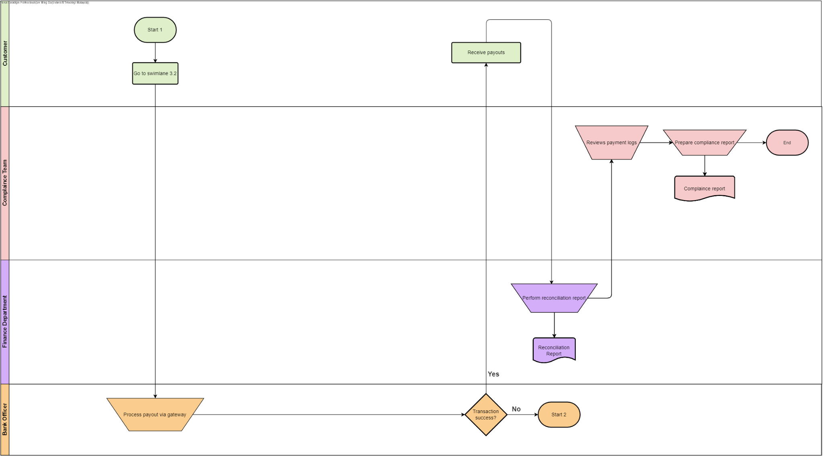
Figure 3.1: Swimlane Diagram of Manual Bank Payout Process

    - Related Documents
The following documents are relevant to the current payout process:
- Payment Log: A detailed log of transactions processed by the gateway, used for initial review.
- Reconciliation Report: The official financial record generated by Finance after reconciliation is complete.
- Payment Report: A document comparing internal authorized orders with bank batch files to identify discrepancies.
- Compliance Report: The final report prepared by Compliance to close the audit loop.

    - Issues in current process
- Heavy reliance on manual processing
Claims verification, approval, bank file preparation, and reconciliation require manual actions by multiple teams. This will increase the processing time, workload, and the potential for delays.
- Batch-based bank transfers cause delays
Payouts are dependent on bank batch windows and operating hours, preventing instant fund access for customers.
- High risk of human error
Manual data entry, bank details matching, and reconciliation increase the likelihood of payout failures and financial discrepancies.
- Complex Error Handling
If a transaction fails at the gateway level ("Transaction success? No"), the process is disrupted and loops back to a start state ("Start 2"), leading to operational inefficiency.

    - Improvement Suggestions
- Implement instant eMoney crediting
Replace slow manual bank transfers with automated digital crediting directly into the customer's Etiqa eMoney account.
- Enable real-time payout notifications
Customers receive immediate alerts upon successful crediting.
- Provide real-time fund visibility
Users can view balances, payout history, and fund status through the Etiqa app.

  - <<Manual Claim Verification & Approval >>
This process details the initial submission of the payout request by the customer, the verification of documents, and the necessary regulatory approvals required before a payout is authorized.
The current claim and approval process involves several internal stakeholders:
- Customer: The initiator who submits the payout request and provides necessary documentation to the Claim Officer.
- Claim Officer: Responsible for verifying the authenticity and completeness of submitted documents against the Internal Claims SOP.
- Compliance Team: Conducts mandatory regulatory checks to ensure the request is legitimate and meets risk standards.
- Finance Department: The final authority in this phase, responsible for reviewing the approval report and authorizing the payout trigger.
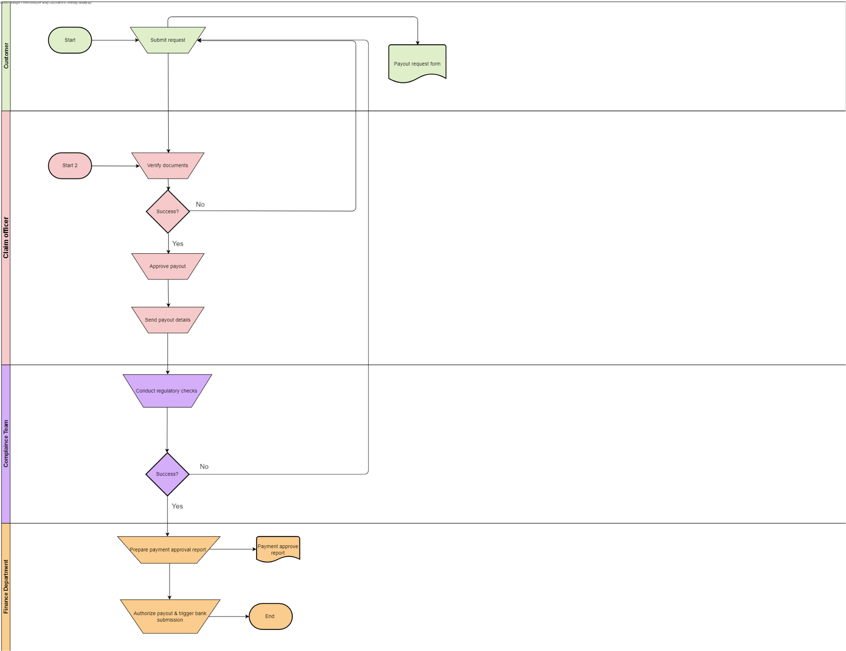
3.2.1 Swimlane Model
Figure 3.2: Swimlane Diagram of <Manual Claim Verification & Approval>

3.2.2 Related Documents
The following documents are utilized or generated during this verification phase:
- Payout Request Form: The initial application form submitted by the customer.
- Internal Claims SOP: Standard Operating Procedures and guidelines used by the Claim Officer to verify the validity of submitted documents.
- Payment Approval Report: The authorization document generated by Compliance and used by Finance to approve the fund release.

3.2.3 Issues in current process
The following problems have been identified in the verification workflow:
- Sequential Handovers: The linear process (Claim Officer -> Compliance Team -> Finance Department) creates bottlenecks. If one party delays, the entire process stalls.
- Manual Rejection Loops: If the Claim Officer rejects documents ("Success? No"), the customer must restart the submission manually, leading to poor user experience and processing delays.
- Lack of Visibility: Customers cannot track the status of their approval in real time and must wait for the final outcome.
- Bottleneck from Commingled Payout Types: Various types of payouts such as claims, refunds, surplus, rewards are funnelled through the same manual verification pipeline. Because these distinct categories are combined into a single workflow, a high volume of requests in one category creates a backlog that delays the processing of all other payout types.

3.2.4 Improvement Suggestions
- Digital KYC & Pre-validation: Use the eMoney system to automatically validate customer identity at the point of submission, reducing manual rejection loops.
- Unified Approval Dashboard: Allow Claims and Compliance teams to review requests in parallel to speed up the authorization time.

4. PROPOSED (TO-BE) PROCESS
4.1 Digital eMoney Payout Process
The customer’s payout is automatically credited into their Etiqa eMoney Wallet. The customer receives real-time notification and can withdraw or reinvest instantly. Finance and compliance teams monitor through automated dashboards.

4.1.1 Swimlane Model
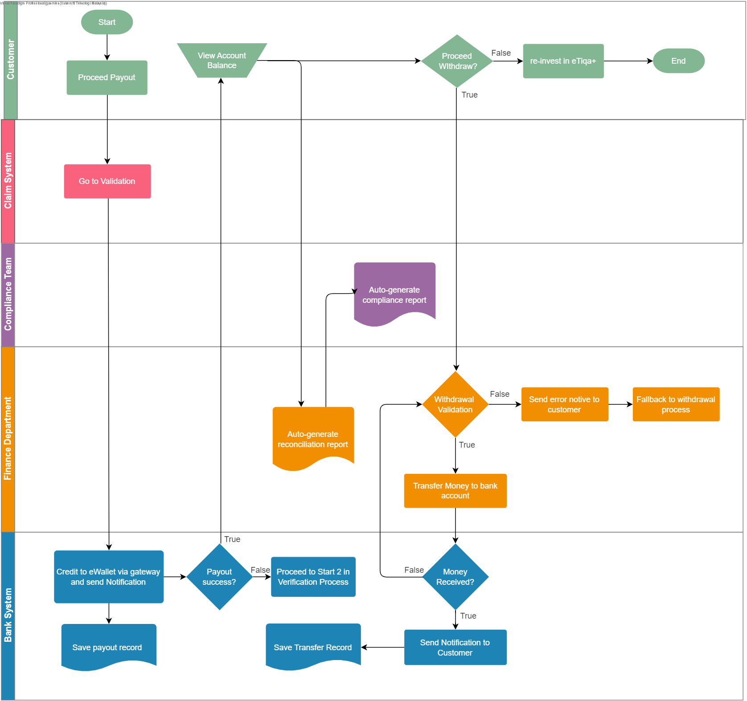
Figure 4.1: Swimlane Diagram of Payout Process

4.1.2 Business Rules
BR1: eMoney transactions must comply with BNM eMoney Guidelines
BR2: System must follow RMiT security controls
BR3: Customers can only use eMoney within Etiqa's closed-loop system
BR4: Funds can be withdrawn only to verified bank accounts
BR5: All transactions must be logged for audit and compliance
BR6: Reinvestment must use approved Etiqa products
BR7: Payout crediting must occur instantly after approval
BR8: Failed transactions must trigger automated retry + alerts
BR9: Identity verification follows KYC/AML requirements

4.2 Digital eMoney Verification Process
When customers proceed to payout, the system will navigate to the verification process. It sends requests to the Claim System and lets it perform document verification. The process is automated and allows the compliance team to view system processes.

4.2.1 Swimlane Model
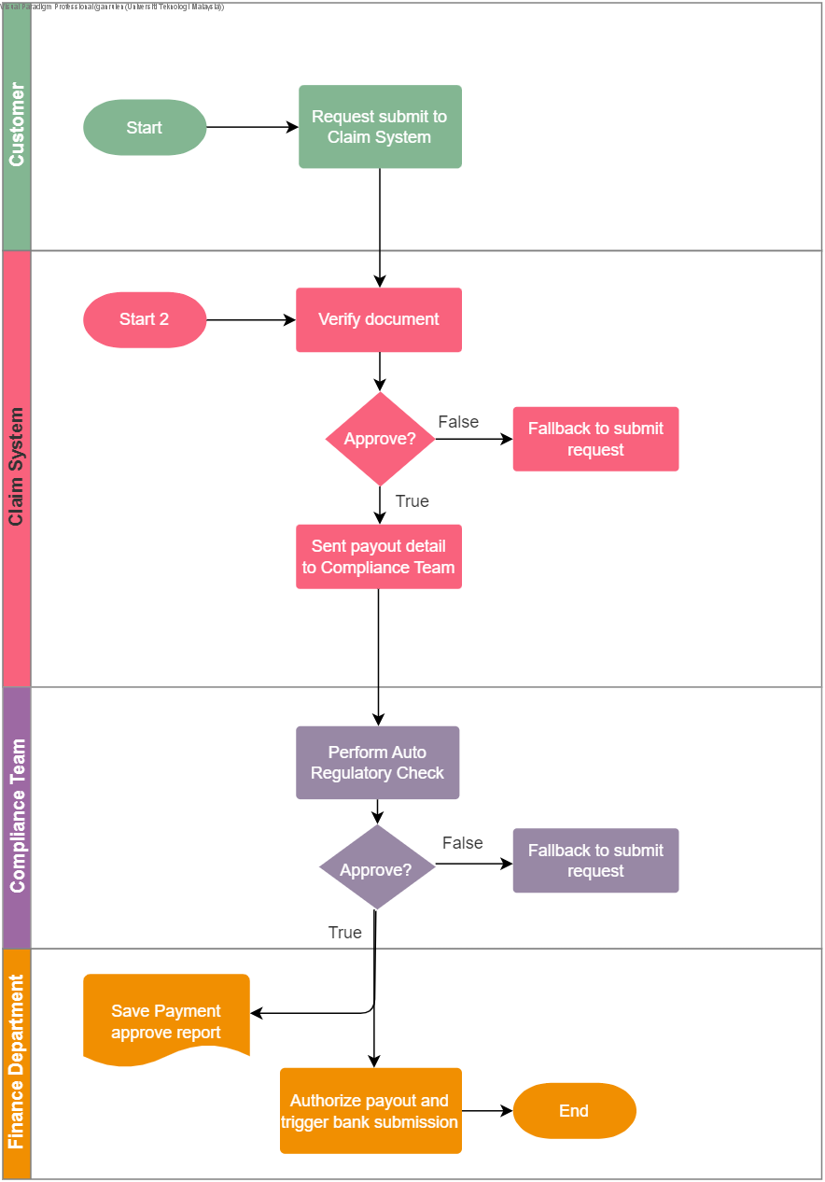
Figure 4.2: Swimlane Diagram of Verification Process

4.2.2 Business Rules
BR1: Claimant and payee identity must meet KYC and AML requirements.
BR2: Claim approval must strictly follow policy terms and conditions.
BR3: All claim and payout data must be logged for audit compliance.
BR4: Payout details are sent to Compliance only after claim approval.
BR5: Automated checks must screen payee against regulatory watchlists.
BR6: Finance Department must authorize all payments before bank submission.
BR7: Payout bank accounts must be verified, belonging to the claimant.
BR8: Failed checks must trigger alerts for manual review and resolution.
BR9: Payment instructions sent to the bank must meet format specifications.
BR10: Total claim processing time must meet the defined SLA.

5. APPENDICES
- Appendix A : Originality/Similarity Report
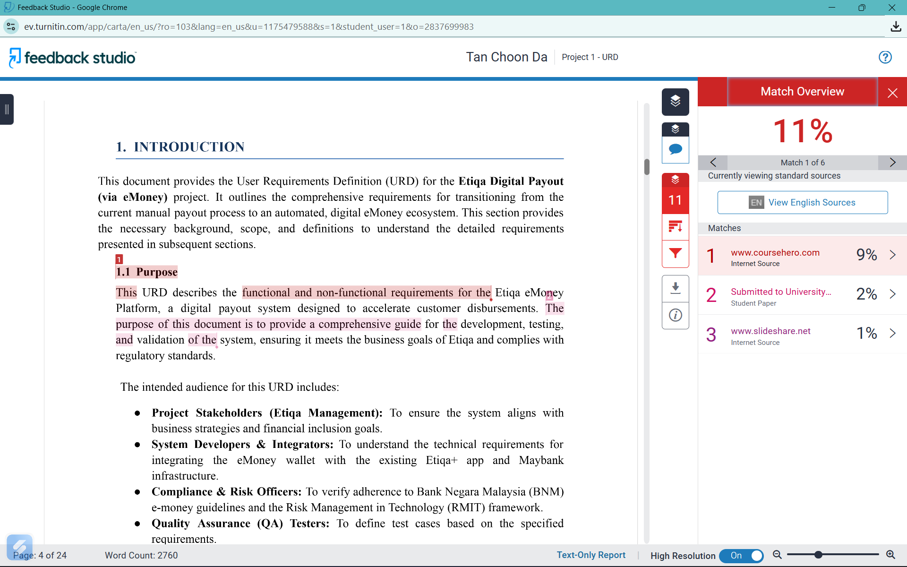
Figure 5.1: Screenshot for originality/ similarity report from Turnitin checking.

- Appendix B : List of Prompts Used
Screenshot:
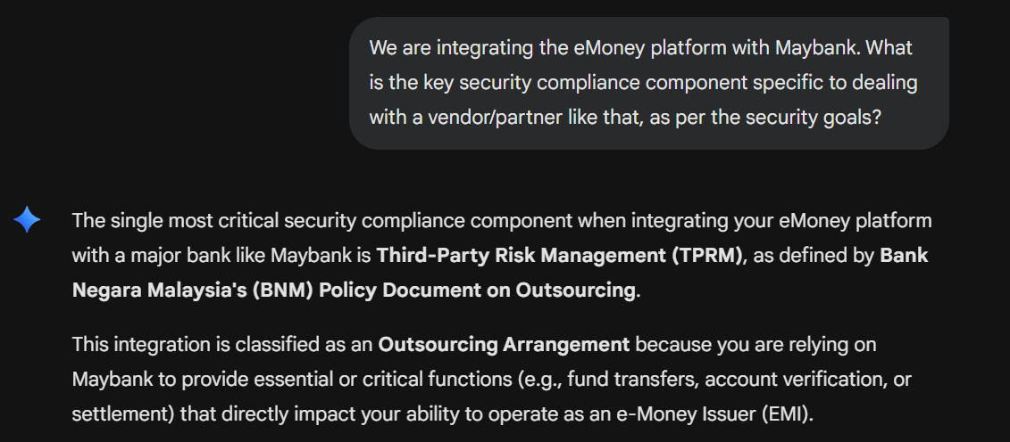
Figure 5.2: Screenshot asking the Generative AI about the key security compliance component

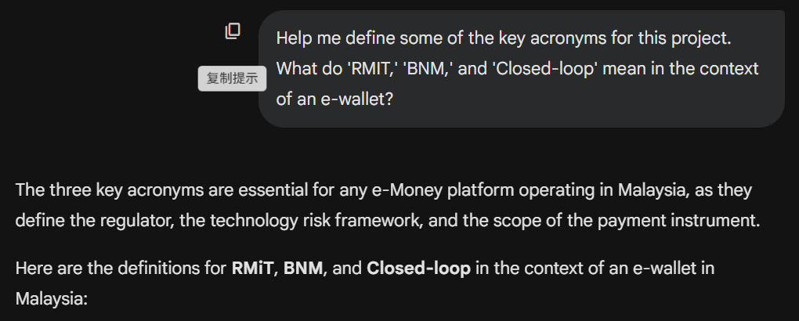
Figure 5.3: Screenshot asking the Generative AI about what RMIT and BNM mean in the context of e-wallet

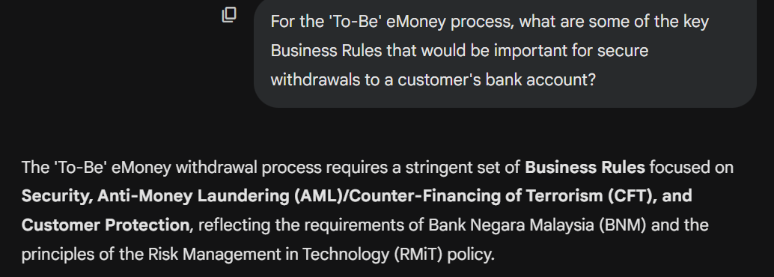
Figure 5.4: Screenshot asking the Generative AI about the key Business Rules that is important for secure withdrawals to a customer’s bank account
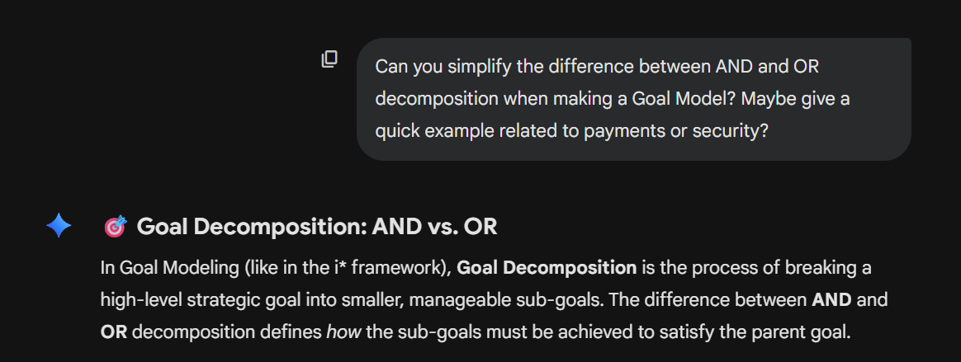
Figure 5.5: Screenshot asking the Generative AI about the difference between AND and OR decomposition while making a goal model

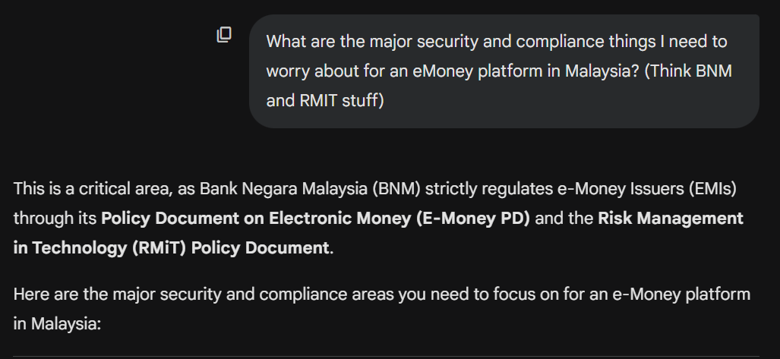
Figure 5.6: Screenshot asking the Generative AI about the major security and compliance things for an eMoney platform in Malaysia
URL: https://gemini.google.com/share/a74ee83291d2

- Appendix C : Screenshot of workshop questioning
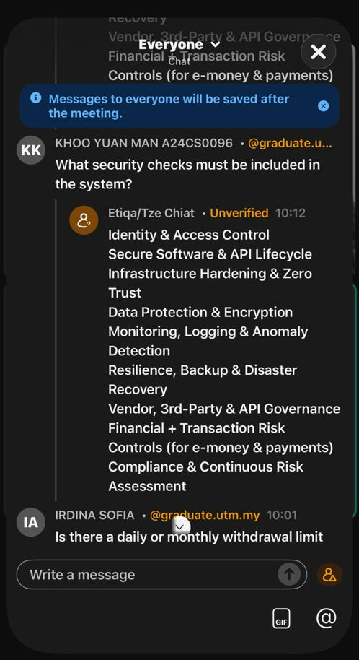
Figure 5.7: Screenshot during the Stakeholders Elicitation Workshop & Brainstorming

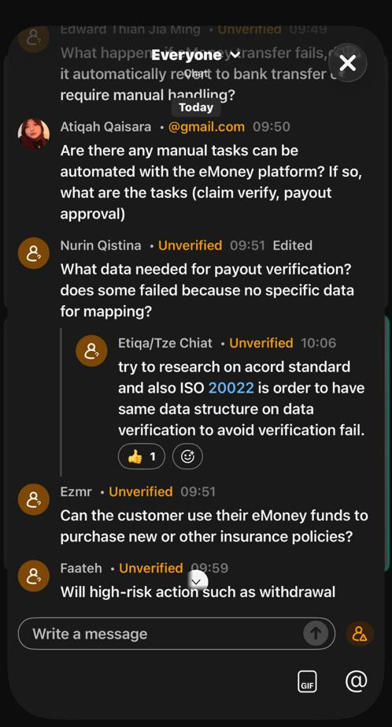
Figure 5.8: Screenshot during the Stakeholders Elicitation Workshop & Brainstorming

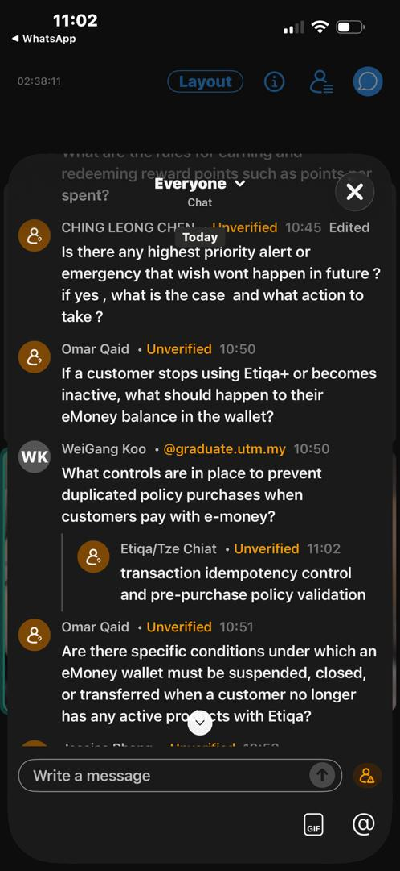
Figure 5.9: Screenshot during the Stakeholders Elicitation Workshop & Brainstorming

Video Presentation Link: https://youtu.be/qhKuM0wAQjM

